**MSEG 410/610**

**Experimental Mechanics of Composite Materials**

**Lab 5: Short Beam Shear and Flexure Lab**

Zachary Swain

*Group Members*

Chunyan Zhang

Evan Minnigh

Jerome Premkumar

Casey Busch

Performed on: April 10&17, 2019 Submitted on: May 3, 2019

**Abstract**

***Objective*:**

The purpose of this lab was to predict and experimentally determine specific mechanical properties of a carbon fiber laminate. This was done by executing experimental 3-point bending experiments for various specimen spans for short beam shear and flexural responses. This provided a better understanding of effective experimental flexural/shearing testing, the mechanical properties that can be obtained from such experiments, and how to use and analyze different property predictions.

***Summary of Results*:**

____________________________________

**Procedure**

***ASTM Standard*:**

The panel was fabricated with a lay-up that will be described by nomenclature and notation as defined in ASTM D 6507. Short beam strength and flexural testing set up and operation were executed in accordance with ASTM D 2344 and ASTM D 790, respectively.

***Specimen Lay-up and Geometries*:**

The unidirectional laminate was fabricated with a [0] lay-up composed of G-83C resin and T700 carbon fiber prepreg.[1] Post-process machining was done to form five [0] specimens, in their respective testing geometries of varying span. These specimens were used to investigate the short beam strength and flexural properties of the panel, and to compare to property prediction. Sampled and averaged specimen geometries can be found in Table 1.

***Instrumentation*:**

An Instron 5567 Universal Testing Machine 3-point bending test setup was used for short beam strength and flexural loading of each respective specimen. Bluehill software suite was used to control and record data measurement. Microsoft Excel was utilized for data reduction purposes.

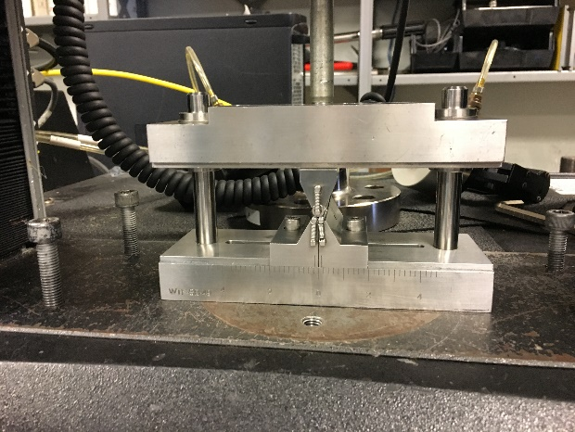 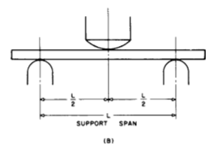

**Fig. 1:** Instron setup for 3-point bending test, **Fig. 2:** 3-point bending test is visualized in

and visualization of compliance check. ASTM D 790

***Instron Settings*:**

The choice of load cell was determined by results obtained in the previous year, where some samples failed at loads ~300lb and others closer to ~1000lb. As such, 3-point bending tests were operated with a 1024lb (5 kN) load cell secured on the Instron. Specimens were loaded at a constant 0.05 in/min crosshead rate for all specimens and spans. Instron input was modulated by the Bluehill software suite.

***Testing Environment*:**

Testing was done in University of Delaware’s Center for Composite Materials, inside a controlled test lab. Appropriate safety equipment was worn. Humidity and ambient temperature levels were not closely monitored.

**Results**

***Data Reduction Scheme*:**

Load and strain data obtained for each specimen tested were recorded and exported to excel. This data, in parallel with geometry specifications, were used to generate stress – strain and shear stress – shear strain curves, compliant with ASTM D3518, to characterize the mechanical properties of the specimen. The results were averaged over the sample set, and standard deviations were then calculated and likewise reported. The resulting properties were compared to those resulting from ROM and CFM models and then analyzed.

***Tables*:**

|  |  |  |  |  |  |
| --- | --- | --- | --- | --- | --- |
| **Avg Width/Thickness (in.)** | **4x** | **8x** | **12x** | **16x** | **32x** |
| **Sample 1 Thickness** | 0.152 | 0.138 | 0.148 | 0.148 | 0.149 |
| **Sample 1 Width** | 0.499 | 0.499 | 0.499 | 0.500 | 0.496 |
| **Sample 2 Thickness** | 0.153 | 0.138 | 0.148 | 0.148 | 0.148 |
| **Sample 2 Width** | 0.499 | 0.499 | 0.499 | 0.498 | 0.498 |
| **Sample 3 Thickness** | 0.152 | 0.137 | 0.148 | 0.147 | 0.146 |
| **Sample 3 Width** | 0.500 | 0.499 | 0.499 | 0.500 | 0.497 |
| **Sample 4 Thickness** | 0.152 | 0.135 | 0.148 | 0.147 | 0.144 |
| **Sample 4 Width** | 0.497 | 0.498 | 0.496 | 0.496 | 0.501 |
| **Sample 5 Thickness** | 0.151 | 0.131 | 0.148 | 0.147 | 0.140 |
| **Sample 5 Width** | 0.499 | 0.498 | 0.501 | 0.500 | 0.495 |
| **Sample 6 Thickness** | 0.151 | 0.129 | 0.148 | 0.147 | 0.137 |
| **Sample 6 Width** | 0.498 | 0.497 | 0.499 | 0.499 | 0.499 |
| **Sample 7 Thickness** | 0.151 | 0.119 | 0.148 | 0.147 | 0.133 |
| **Sample 7 Width** | 0.525 | 0.523 | 0.520 | 0.520 | 0.514 |

**Table 1:** Sampled and averaged specimen dimensions

|  |  |  |  |  |  |
| --- | --- | --- | --- | --- | --- |
| **Span/Thickness** | **4x** | **8x** | **12x** | **16x** | **32x** |
| **Span (in)** | 0.6 | 1.0 | 1.8 | 2.4 | 4.5 |
| **#1 m_t** | 40017 | 19046 | 9901 | 4996 | 911 |
| **#2 m_t** | 41774 | 20632 | 9980 | 5027 | 856 |
| **#3 m_t** | 41629 | 18513 | 10522 | 5131 | 846 |
| **#4 m_t** | 41657 | 16962 | 10068 | 4691 | 793 |
| **#5 m_t** | 40898 | 17219 | 9317 | 4392 | 727 |
| **#6 m_t** | 40099 | 16672 | 9938 | 4044 | 645 |
| **#7 m_t** | 36465 | 14635 | 7826 | 3618 | 593 |
|  |  |  |  |  |  |
| **Avg m_t (lbf/in)** | 41012 | 18174 | 9954 | 4713 | 767 |
| **m_t s.d.** | 802 | 1520 | 386 | 426 | 70 |
|  |  |  |  |  |  |
| **m_s (lbf/in)** | 63973 | 21611 | 10904 | 4916 | 773 |
| **E_B (psi)** | 1959558 | 4679438 | 9769286 | 10654788 | 12292549 |

**Table 2:** Slope of load-deflection curve is calculated for each specimen (m_t) and averaged to interpret how the load-deflection slope changes over the varying Span/Thickness ratios. The averaged m_t’s are then corrected (m_s) by inverse subtraction of the compliance curve slope. E_B is then calculated using this m_s.

|  |  |  |  |  |  |
| --- | --- | --- | --- | --- | --- |
| **Span/Thick** | **4x** | **8x** | **12x** | **16x** | **32x** |
| **Avg D (in)** | 0.0517 | 0.0534 | 0.0844 | 0.1338 | 0.3132 |
| **P (lb)** | 1143 | 683 | 598 | 450 | 235 |
| **σ_f (psi)** | 88728 | 117128 | 146908 | 149340 | 157526 |
| **σ_f (approx)** | - | - | - | 150086 | 160720 |
| **ε_f** | 0.1311 | 0.0423 | 0.0231 | 0.0205 | 0.0132 |
| **E_x (psi)** | 1256243 | 3935184 | 8918245 | 10215292 | 12210004 |

**Table 3:** Maximum deflection of the center of the beam (D) is averaged for all specimens, the maximum load before failure (P) is reported, Flexural Stress (σ_f) and large deflection approximation of Flexural Stress (σ_f (approx)) is calculated where valid, Flexural Strain (ε_f) is calculated and reported, and average Apparent Flexural Modulus is found for each sample set.

|  |  |  |  |  |  |
| --- | --- | --- | --- | --- | --- |
| **Span/Thick** | **4x** | **8x** | **12x** | **16x** | **32x** |
| **R (in/min)** | 0.0040 | 0.0141 | 0.0355 | 0.0629 | 0.2429 |
| **avg Max Load (lb)** | 1143.4 | 683.0 | 598.3 | 450.0 | 235.3 |
| **F_sbs (psi)** | 11254 | 7708 | 6042 | 4565 | 2480 |
| **S** | 8.7851 | 2.1237 | 0.3783 | 0.2033 | 0.00676 |
| **G13 (psi)** | 134700 | 200593 | 347512 | 363712 | 3111850 |

**Table 4:** Corrected crosshead rates (R) is calculated for each specimen span and thickness, the average maximum load that each sample withstood is averaged for each Span/Thickness ratio, averaged Short-Beam Strength (F_sbs) is reported for each sample set, S correction for shear deformation is calculated and reported, and G13 is backed out from equating S.

***Graphs of Stress-Strain Data*:**

**Fig 3:** Load – deflection curves of 4x samples #1-7.

**Fig 4:** Load – deflection curves of 8x samples #1-7.

**Fig 5:** Load – deflection curves of 12x samples #1-7.

**Fig 6:** Load – deflection curves of 16x samples #1-7.

**Fig 7:** Load – deflection curves of 32x samples #1-7.

***Equations***

***(1)***



***MT=Experimental, MM=Compliance (2)***



***(3)***



***(4)***



***C:\Users\zswain\AppData\Local\Microsoft\Windows\INetCache\Content.Word\SBS.PNG (5)***

***, C:\Users\zswain\AppData\Local\Microsoft\Windows\INetCache\Content.Word\S.PNG (6)***



***Summary of Test Results*:**

It is important to note that all tests were conducted at a constant crosshead rate of 0.05 in/min, as opposed to a rate corrected for significant geometric differences in the specimens. These corrected crosshead rates are calculated by equation 1, and are presented in Table 4. From the Load – Deflection plots of each sample set it is apparent that specimens withstand a greater deflection with increasing Span/Thickness, as well as exhibit a more linear response (albeit of lesser slope). These factors all promote the idea of a transition from shearing to flexure response as Span/Thickness ratio of the specimen increases. As reported in Table 2, the corrected slope of load to displacement (equation 2) decreases by a factor of ~80 from 4x to 32x Span/Thickness ratio, withstanding ~5 times less force (Appendix A), and necessarily seeing significant increase in deflection (Appendix A). Table 3 presents the findings that flexural stress (equation 3) doubles, and apparent flexural modulus (equation 4) is seen to increase roughly 10-fold between 4x-32x.

Midspan deflection is found by utilizing tensile and compressive properties of the material and via data reduction of the 3-point bend testing (Appendix A), the latter is to be used here. In table 4, it is shown that shearing stress (equation 5) sees a ~5x decrease over the varying spans. Apparent flexural modulus is plotted against respective span/thickness, and the resultant curve (Fig. 10) is accepted, as it is seen to plateau with increasing span – where it would approach the laminate’s tensile modulus. Large deviation from this value as low span/thickness ratios is prompts the assertion that these cases are shear stress dominated, while the larger spans see a flexure dominated response. As such, span/thickness ratios of 4x and 8x are determined to have shear dominated responses and ratios of 16x and 32x are said to have flexure dominated responses, while 12x sees a transition between the two. When interlaminar shear modulus is calculated using deflection incorporating shear deformation (equation 6), a result of 12.3 Msi is found.

**Fig 8:** Flexural Stress is plotted for Span/Thickness ratios of 4, 8, 12, 16, 32.

**Fig 9:** Shear Stress is plotted for Span/Thickness ratios of 4, 8, 12, 16, 32.

**Fig 10:** Apparent Flexural Modulusis plotted for Span/Thickness ratios of 4, 8, 12, 16, 32.

***Description of Failure Modes:***

All specimens were seen to experience either interlaminar shear failure or flexure failure, as defined in ASTM D 2344 (Fig. 11). Upon inspection, shorter spans (4x, 8x, and 12x) failed by delamination, classically resultant of interlaminar shearing (Fig. 12). Larger spans failed under compressive and tensile failures, indicative of flexure (Fig. 13).

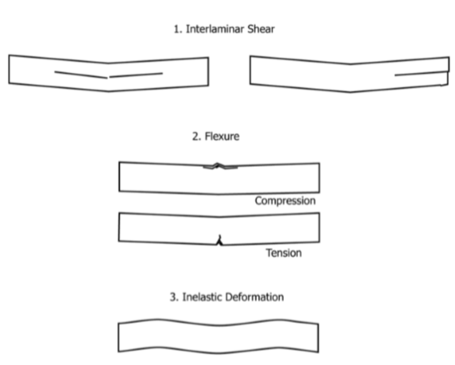

**Fig 11**: Shearing and Flexural failure modes as defined in ASTM D 2344.

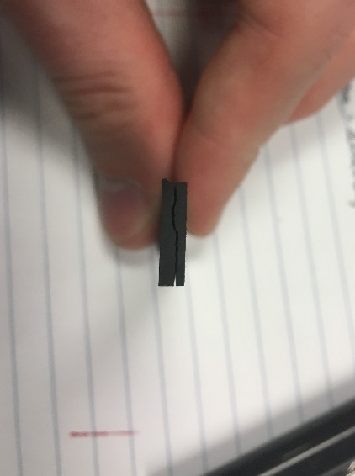 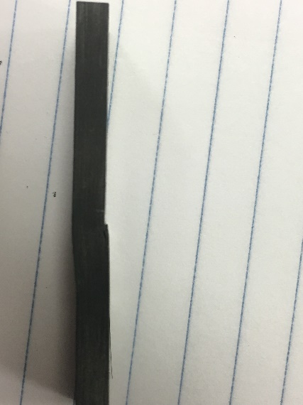

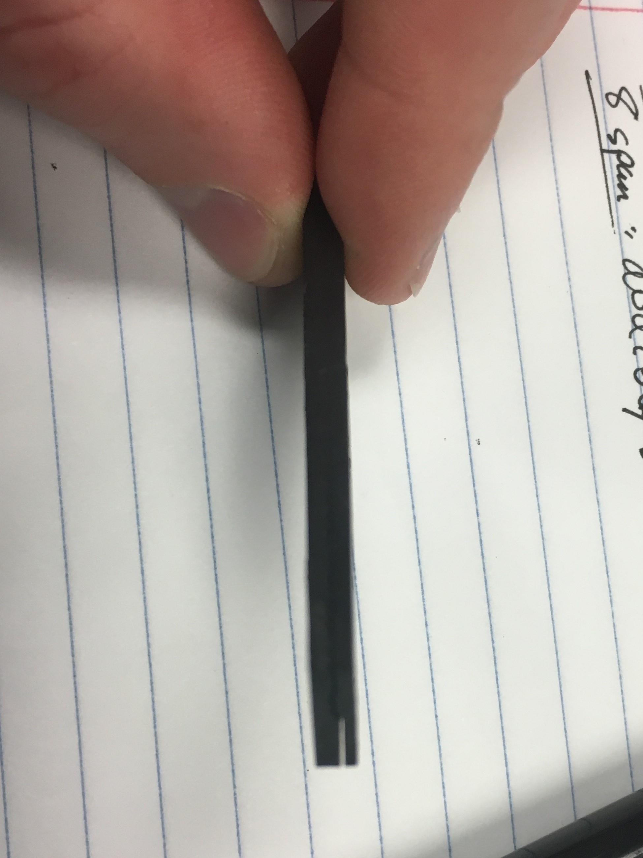

**Fig. 12:** Interlaminar shearing failure is seen at lower Span/Thickness ratios, 4x, 8x, and 12x.

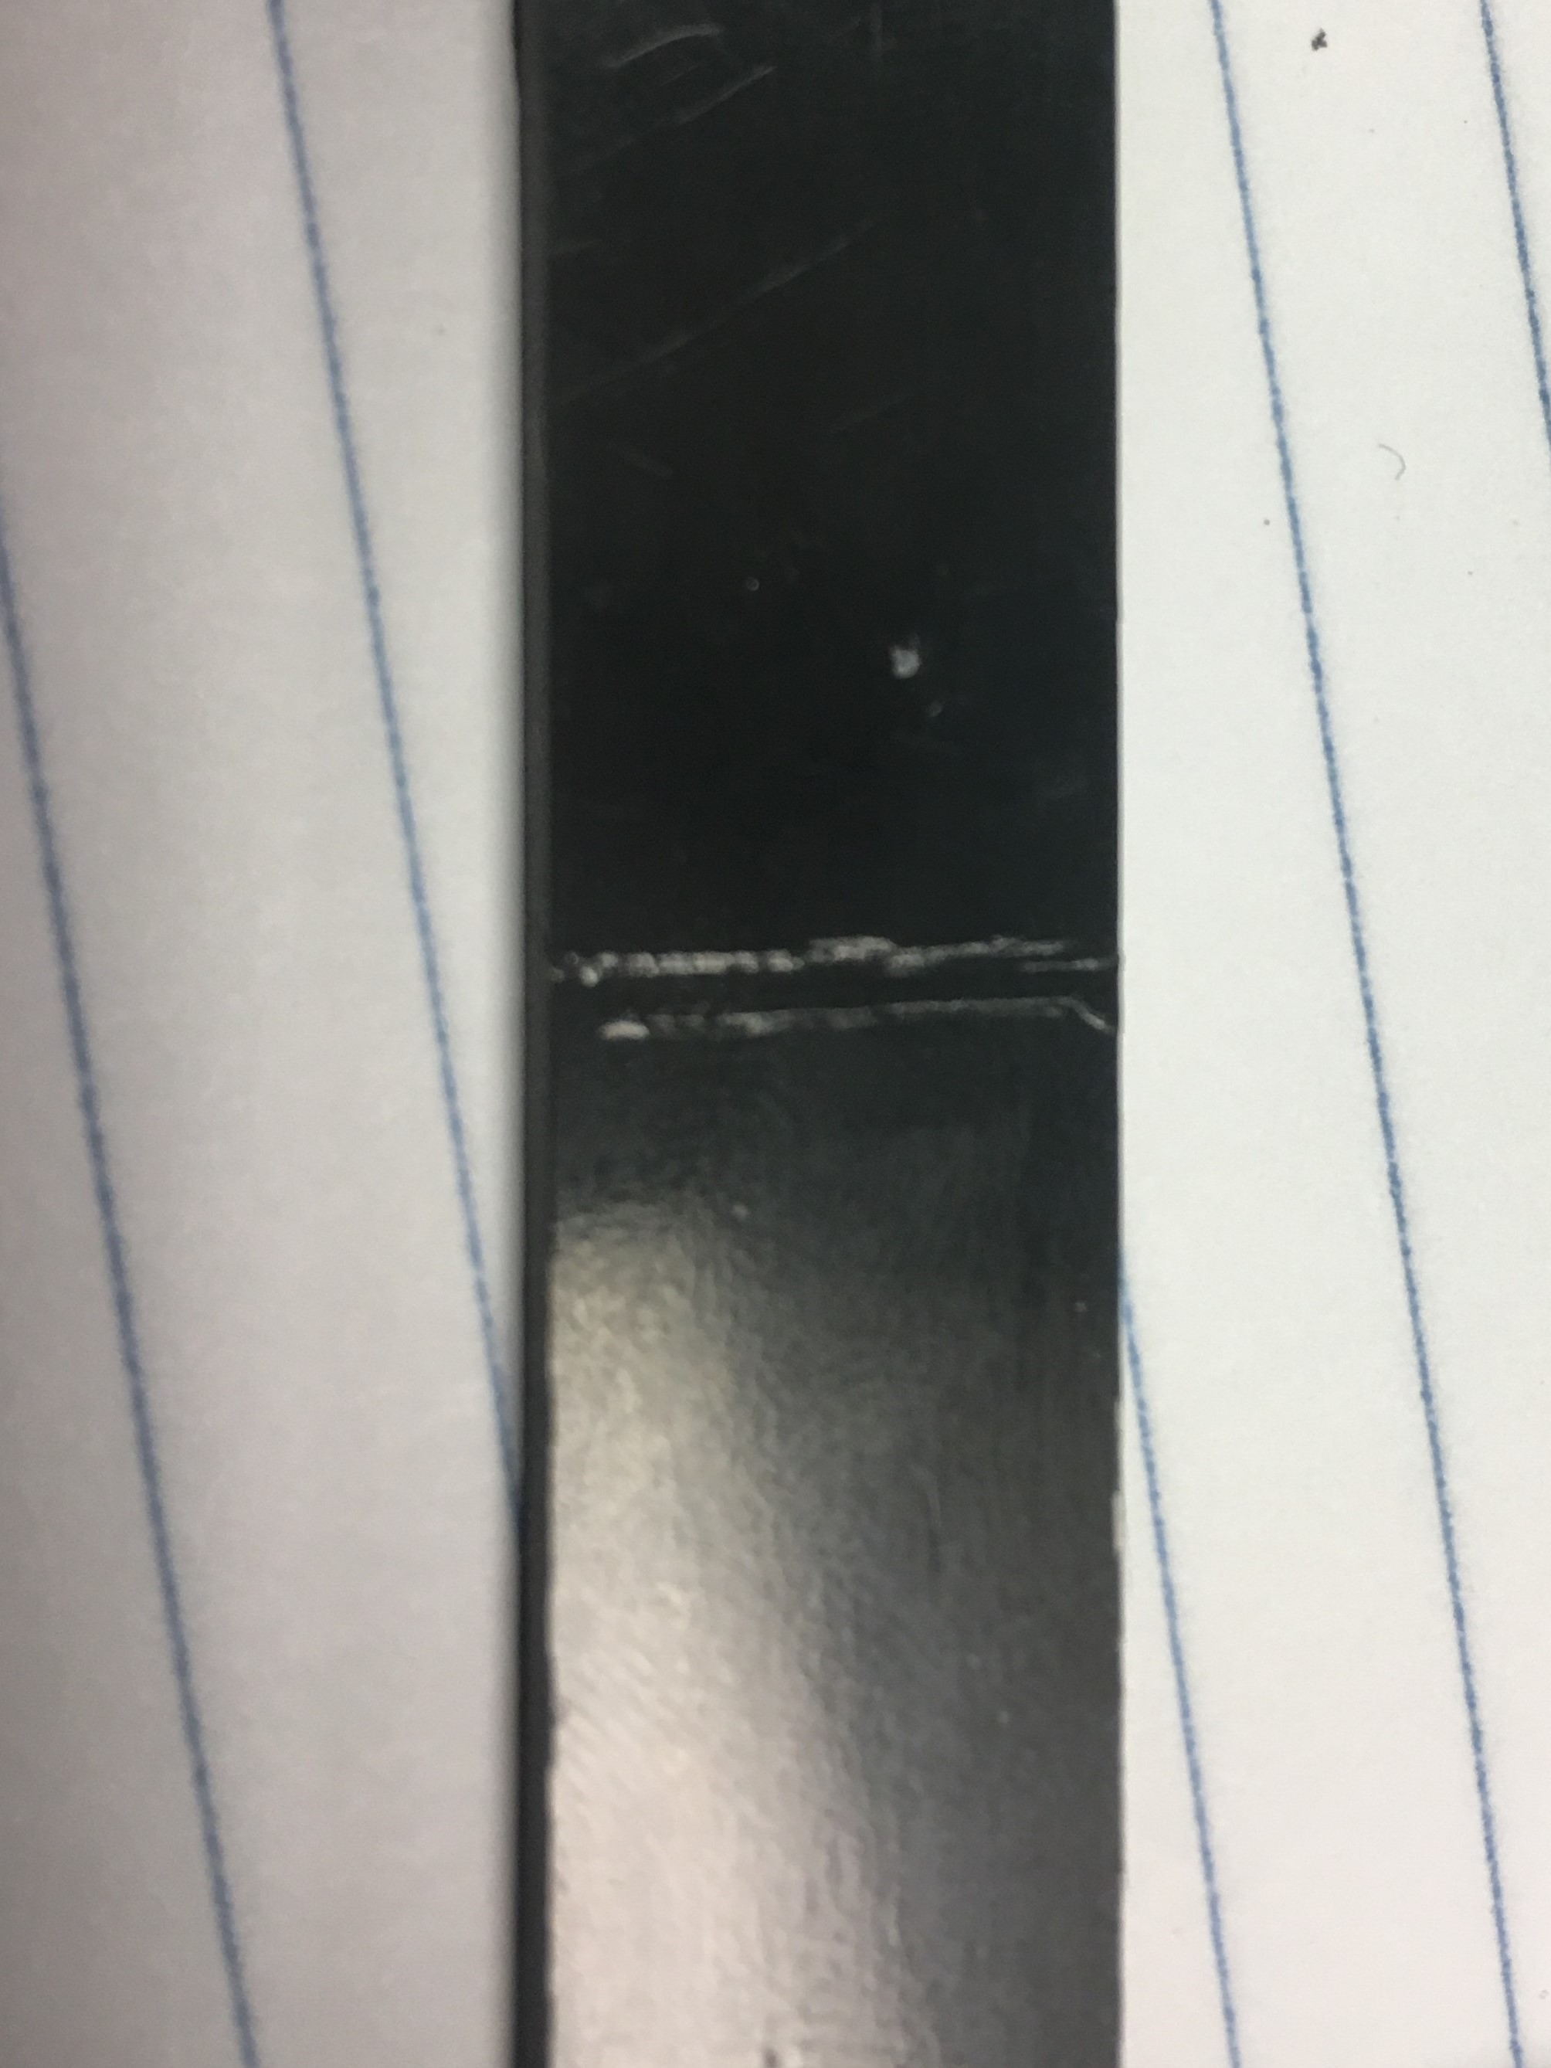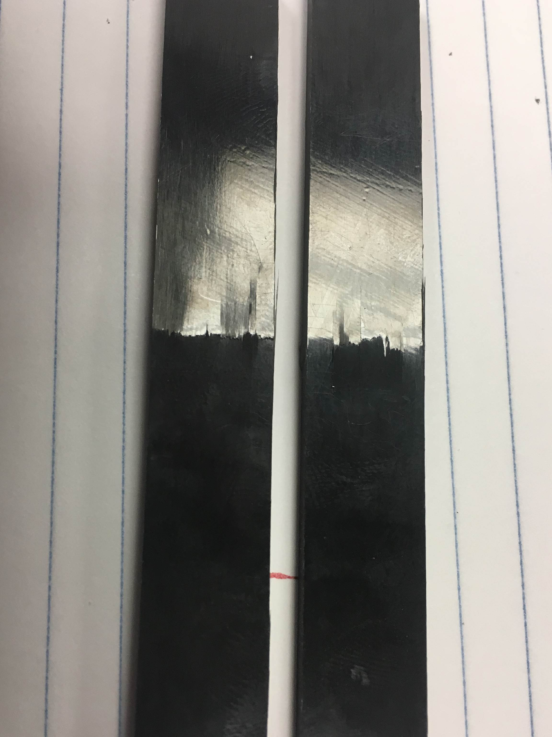

**Fig. 13:** Flexural failure is seenin longer Span/Thickness ratios 16x and 32x.

**Correlation of Theory and Experiments**

Cracking/delamination at the midplane can be said to be induced by interlaminar shear, as the flexural stress will be at a minimum here and maximized at the surfaces. This is due to a transition from compression to tension from top to bottom, through-thickness. Likewise, failure seen to occur at either surface can be said to be induced by flexure, as shear stress sees a minimum at the surface. Compressive and tensile failure (top and bottom surfaces, respectively) were both seen to occur, which may at first be counter-intuitive, but it is important to note that the loading point of the Instron can induce through-thickness compression which will strengthen against buckling etc. The result is an induced tension failure on the bottom surface (visualized by cracking across the width of the sample). Otherwise, the sample will fail in compression at higher spans due to a compression strength that is ~50% of the high tensile strength.

**Conclusions**

Unidirectional [0] laminate samples were machined to median 0.15” thickness, by 0.5” width, and tested by varying span of 4x, 8x, 12x, 16x, and 32x thickness. These samples underwent 3-point bending tests to investigate the effect of span/thickness ratio on shear stress and flexure dominated properties. It is concluded that 4x and 8x span/thickness have shear dominated responses and ratios of 16x and 32x have flexure dominated responses, with 12x placed in a transitive zone. These results can be utilized to design composite parts that establish interlaminar shearing failure prior to flexural failure. It is also useful to note that flexure testing is best implemented at minimized spans, as to negate the impact of moments acting in non-small-angles with respect to the axis of loading.

**References**

[1] T700S Data Sheet [PDF]. Santa Ana, CA: Toray Carbon Fibers America Inc. <https://www.toraycma.com/file_viewer.php?id=4459>.

[2] ASTM Standard D2344, “Short-Beam Strength of Polymer Matrix Composite Materials and Their Laminates,” ASTM International, West Conshohocken, PA, 2003, [www.astm.org/Standards/D3518.htm](http://www.astm.org/Standards/D3518.htm)

[3] ASTM Standard D790, “Flexural Properties of Unreinforced and Reinforced Plastics and Electrical Insulating Materials,” ASTM International, West Conshohocken, PA, 2003, [www.astm.org/Standards/D3039.htm](http://www.astm.org/Standards/D3039.htm)

**Appendix A**

**Fig. 14**: Shear stress plateau for rapidly increasing shear strain in specimen #2.

**Fig. 14**: Shear stress plateau for rapidly increasing shear strain in specimen #2.

**Fig. 14**: Shear stress plateau for rapidly increasing shear strain in specimen #2.

**Fig. 14**: Shear stress plateau for rapidly increasing shear strain in specimen #2.

**Fig. 14**: Shear stress plateau for rapidly increasing shear strain in specimen #2.

**Fig. 14**: Shear stress plateau for rapidly increasing shear strain in specimen #2.

**Fig. 14**: Shear stress plateau for rapidly increasing shear strain in specimen #2.

**Fig. 14**: Shear stress plateau for rapidly increasing shear strain in specimen #2.

**Fig. 14**: Shear stress plateau for rapidly increasing shear strain in specimen #2.

**Fig. 14**: Shear stress plateau for rapidly increasing shear strain in specimen #2.

**Fig. 14**: Shear stress plateau for rapidly increasing shear strain in specimen #2.

**Fig. 14**: Shear stress plateau for rapidly increasing shear strain in specimen #2.

**Fig. 14**: Shear stress plateau for rapidly increasing shear strain in specimen #2.

**Fig. 14**: Shear stress plateau for rapidly increasing shear strain in specimen #2.

**Fig. 14**: Shear stress plateau for rapidly increasing shear strain in specimen #2.

**Fig. 14**: Shear stress plateau for rapidly increasing shear strain in specimen #2.

**Fig. 14**: Shear stress plateau for rapidly increasing shear strain in specimen #2.

**Fig. 14**: Shear stress plateau for rapidly increasing shear strain in specimen #2.

**Fig. 14**: Shear stress plateau for rapidly increasing shear strain in specimen #2.

**Fig. 14**: Shear stress plateau for rapidly increasing shear strain in specimen #2.

**Fig. 14**: Shear stress plateau for rapidly increasing shear strain in specimen #2.

**Fig. 14**: Shear stress plateau for rapidly increasing shear strain in specimen #2.

**Fig. 14**: Shear stress plateau for rapidly increasing shear strain in specimen #2.

**Fig. 14**: Shear stress plateau for rapidly increasing shear strain in specimen #2.

**Fig. 14**: Shear stress plateau for rapidly increasing shear strain in specimen #2.

**Fig. 14**: Shear stress plateau for rapidly increasing shear strain in specimen #2.

**Fig. 14**: Shear stress plateau for rapidly increasing shear strain in specimen #2.

**Fig. 14**: Shear stress plateau for rapidly increasing shear strain in specimen #2.

**Fig. 14**: Shear stress plateau for rapidly increasing shear strain in specimen #2.

**Fig. 14**: Shear stress plateau for rapidly increasing shear strain in specimen #2.

**Fig. 14**: Shear stress plateau for rapidly increasing shear strain in specimen #2.

**Fig. 14**: Shear stress plateau for rapidly increasing shear strain in specimen #2.

**Fig. 14**: Shear stress plateau for rapidly increasing shear strain in specimen #2.

**Fig. 14**: Shear stress plateau for rapidly increasing shear strain in specimen #2.

**Fig. 14**: Shear stress plateau for rapidly increasing shear strain in specimen #2.

**Fig. 14**: Shear stress plateau for rapidly increasing shear strain in specimen #2.

**Fig. 14**: Shear stress plateau for rapidly increasing shear strain in specimen #2.

**Fig. 14**: Shear stress plateau for rapidly increasing shear strain in specimen #2.

**Fig. 14**: Shear stress plateau for rapidly increasing shear strain in specimen #2.

**Fig. 14**: Shear stress plateau for rapidly increasing shear strain in specimen #2.

**Fig. 14**: Shear stress plateau for rapidly increasing shear strain in specimen #2.

**Fig. 14**: Shear stress plateau for rapidly increasing shear strain in specimen #2.

**Fig. 14**: Shear stress plateau for rapidly increasing shear strain in specimen #2.

**Fig. 14**: Shear stress plateau for rapidly increasing shear strain in specimen #2.

**Fig. 14**: Shear stress plateau for rapidly increasing shear strain in specimen #2.

**Fig. 14**: Shear stress plateau for rapidly increasing shear strain in specimen #2.

**Fig. 14**: Shear stress plateau for rapidly increasing shear strain in specimen #2.

**Fig. 14**: Shear stress plateau for rapidly increasing shear strain in specimen #2.

**Fig. 14**: Shear stress plateau for rapidly increasing shear strain in specimen #2.

**Fig. 14**: Shear stress plateau for rapidly increasing shear strain in specimen #2.

**Fig. 14**: Shear stress plateau for rapidly increasing shear strain in specimen #2.

**Fig. 14**: Shear stress plateau for rapidly increasing shear strain in specimen #2.

v **Fig. 14**: Shear stress plateau for rapidly increasing shear strain in specimen #2.

**Fig. 14**: Shear stress plateau for rapidly increasing shear strain in specimen #2.

**Fig. 14**: Shear stress plateau for rapidly increasing shear strain in specimen #2.

**Fig. 14**: Shear stress plateau for rapidly increasing shear strain in specimen #2.

**Fig. 14**: Shear stress plateau for rapidly increasing shear strain in specimen #2.

**Fig. 14**: Shear stress plateau for rapidly increasing shear strain in specimen #2.

**Fig. 14**: Shear stress plateau for rapidly increasing shear strain in specimen #2.

**Fig. 14**: Shear stress plateau for rapidly increasing shear strain in specimen #2.

**Fig. 14**: Shear stress plateau for rapidly increasing shear strain in specimen #2.

**Fig. 14**: Shear stress plateau for rapidly increasing shear strain in specimen #2.

**Fig. 14**: Shear stress plateau for rapidly increasing shear strain in specimen #2.

**Fig. 14**: Shear stress plateau for rapidly increasing shear strain in specimen #2.

**Fig. 14**: Shear stress plateau for rapidly increasing shear strain in specimen #2.

**Fig. 14**: Shear stress plateau for rapidly increasing shear strain in specimen #2.

**Fig. 14**: Shear stress plateau for rapidly increasing shear strain in specimen #2.

**Fig. 14**: Shear stress plateau for rapidly increasing shear strain in specimen #2.

**Fig. 14**: Shear stress plateau for rapidly increasing shear strain in specimen #2.

**Fig. 14**: Shear stress plateau for rapidly increasing shear strain in specimen #2.